Souramita Datta ( DE-DBX)

- Created storage Account -> sdattastore

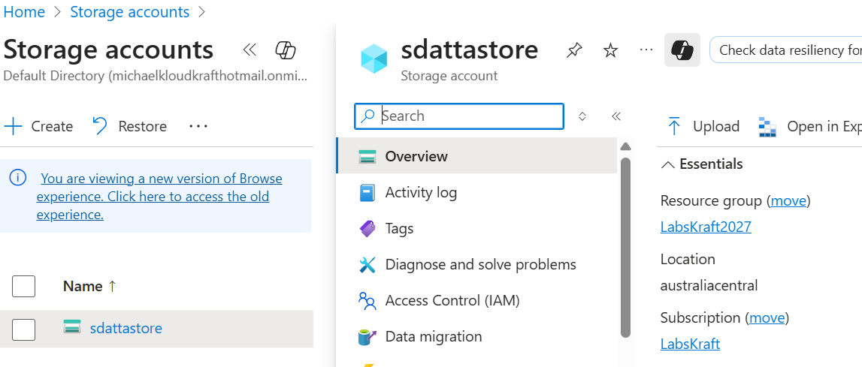
- Created containers , Uploaded dataset retail-iot-data in container rawsdatta

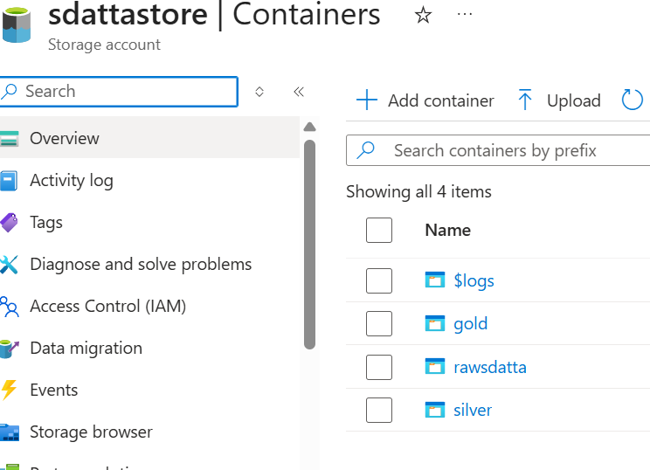

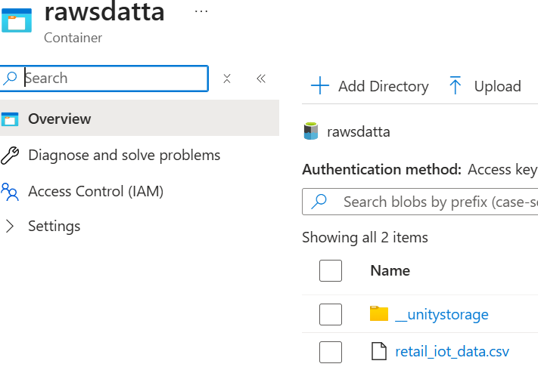

- Created access connector -> capstone_retail-connector-sdatta

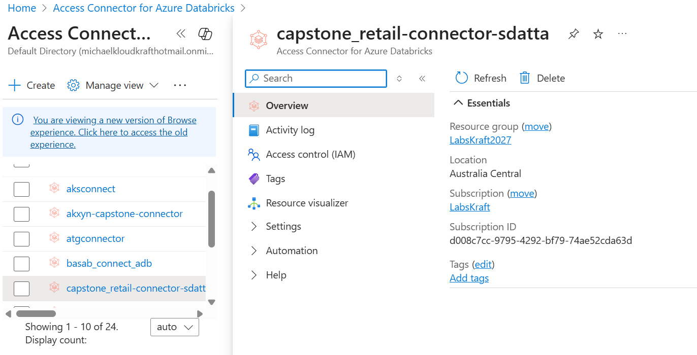
4. Given storage blob contributor and contributor access for storage account
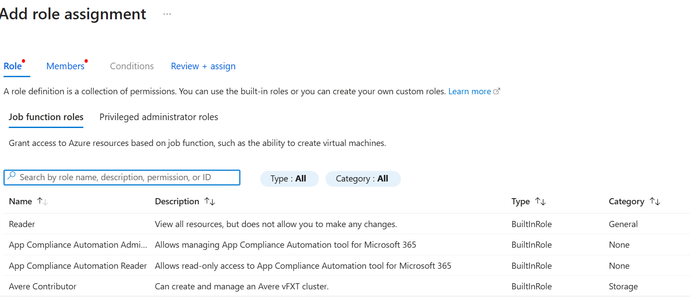
5. Creating catalog -> capstone_retail-sdatta
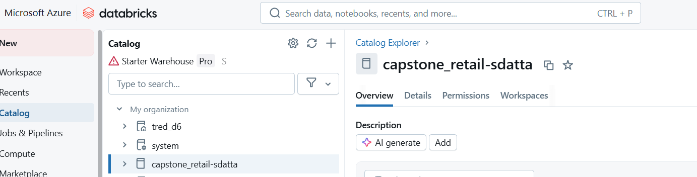
6. Created schema inside catalog -> Bronze ,Silver,Gold

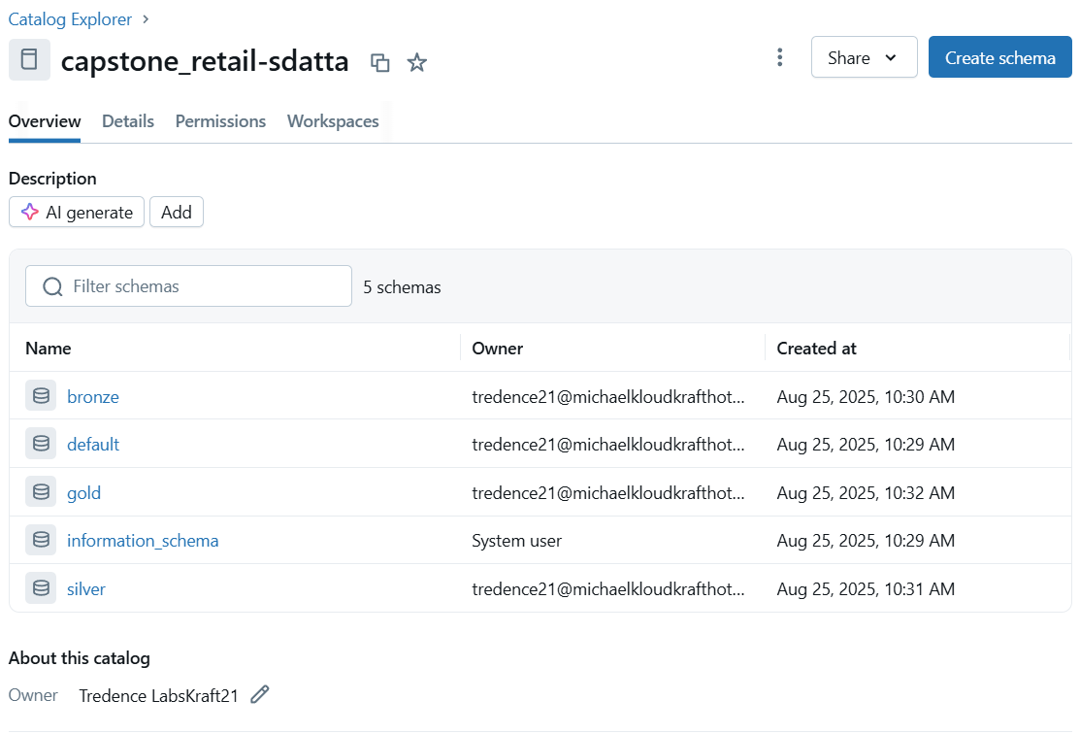
7. Created workspace in data bricks -> capstone-project1
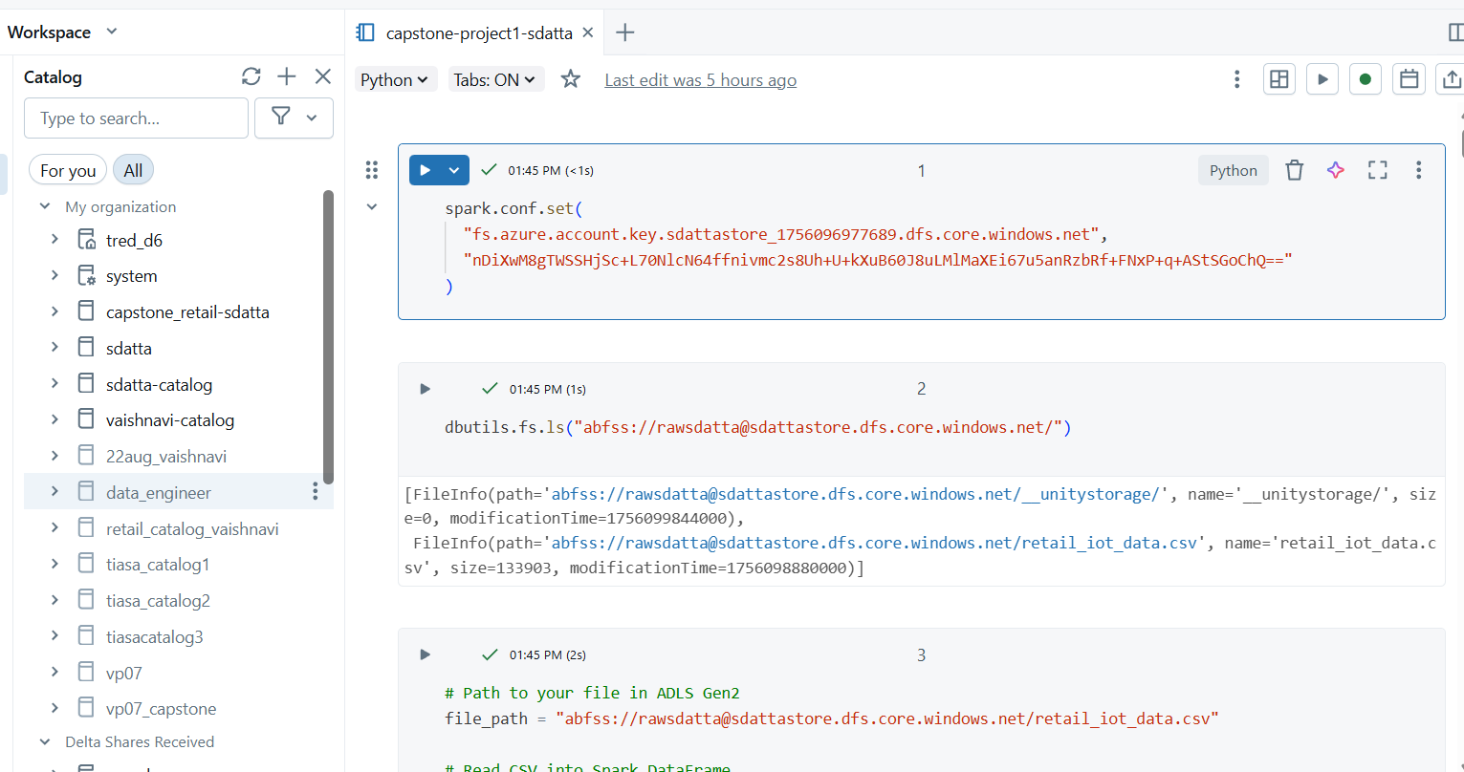
8. Push raw data to bronze schema
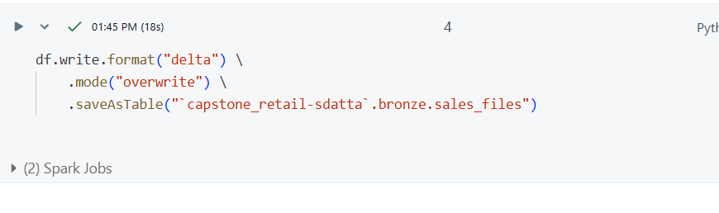
9.Transform data in bronze layer and push to silver schema
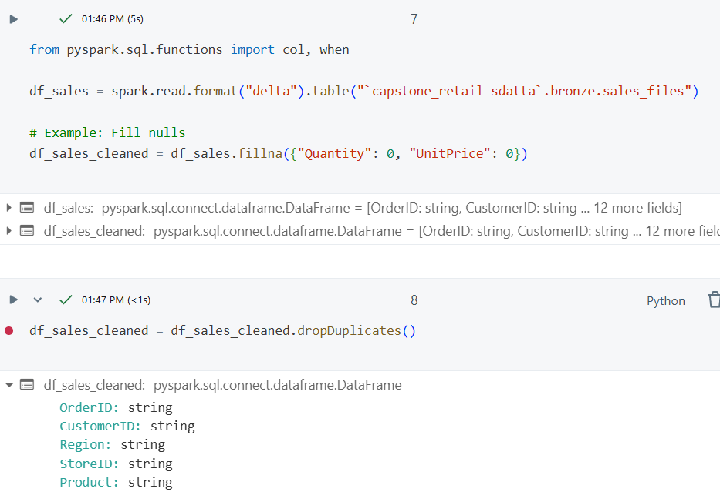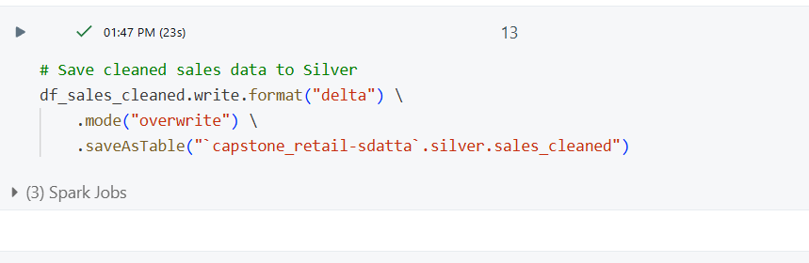

10. Perform aggregation functions on data of silver layer
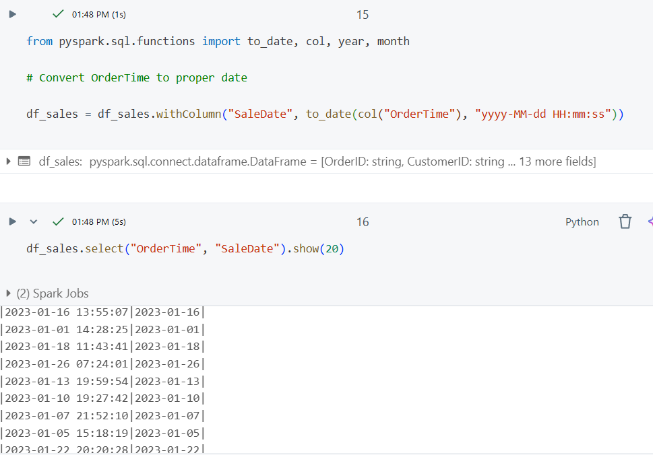
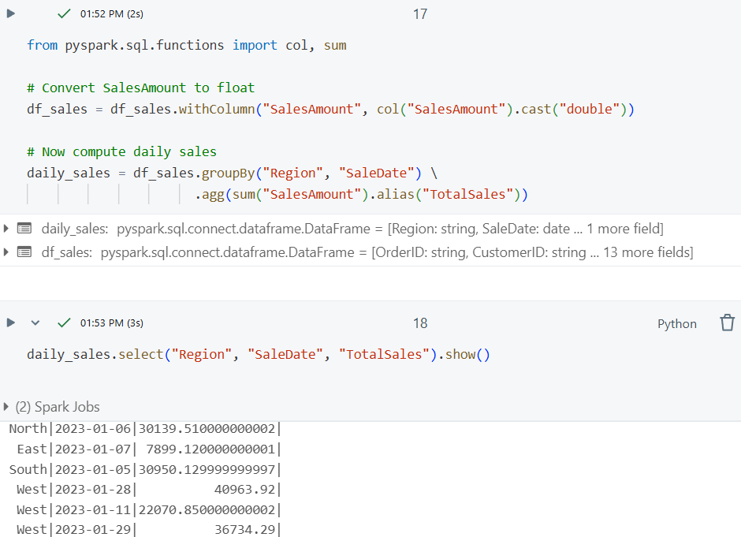
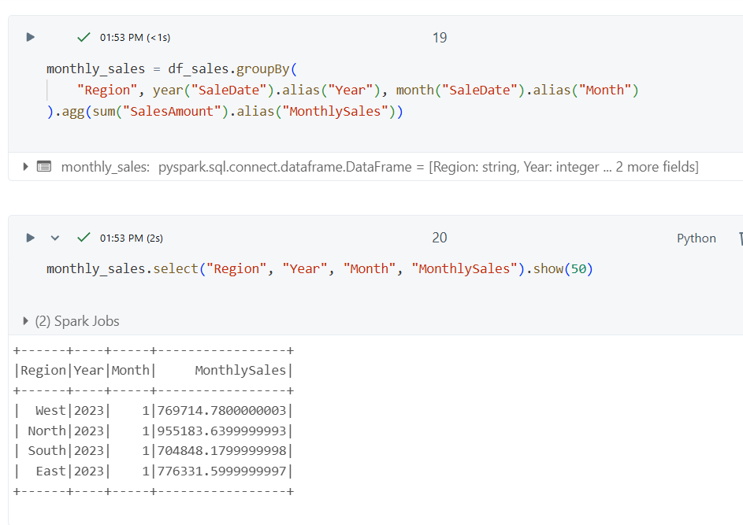
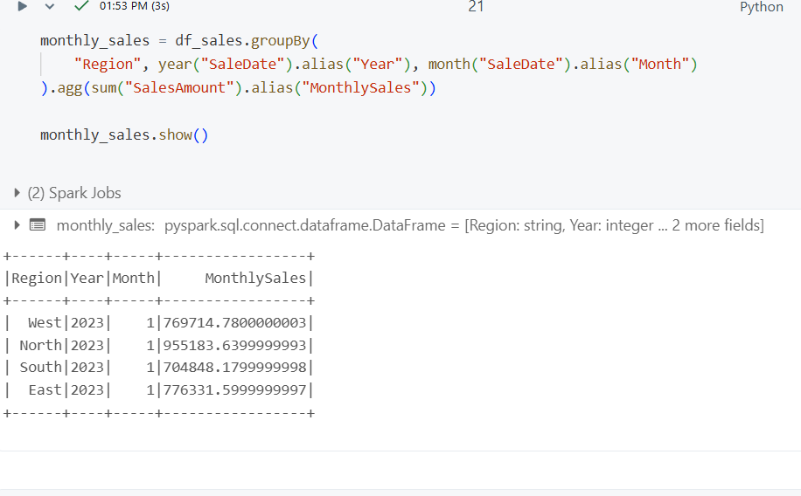

Anomaly trends
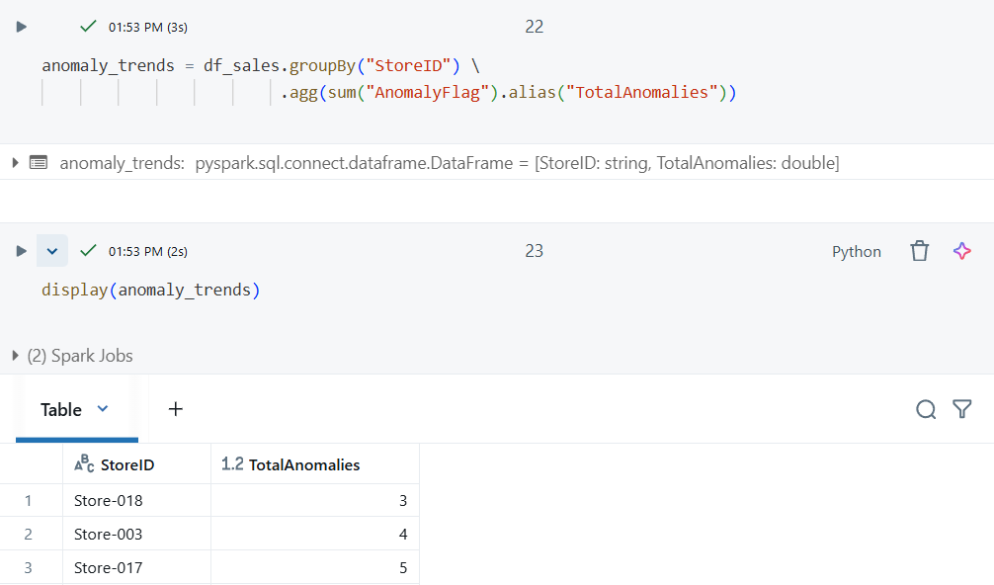
Store performance
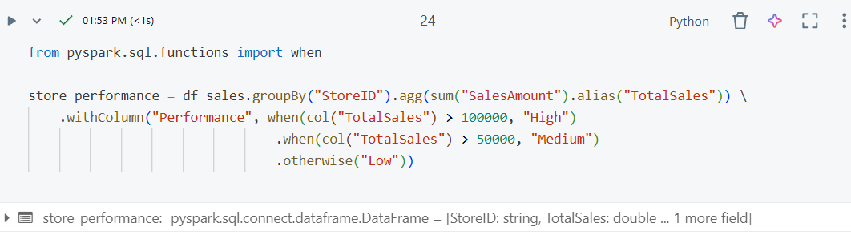

Join sales vs anomilies
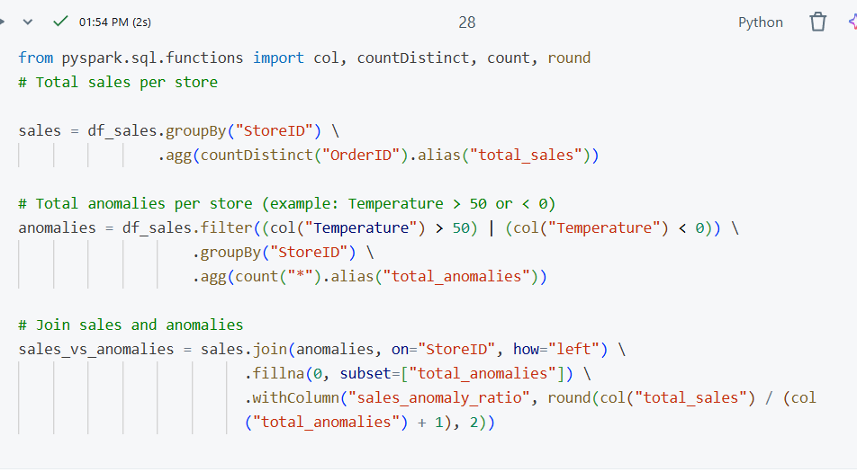
11. Save all the files to gold schema
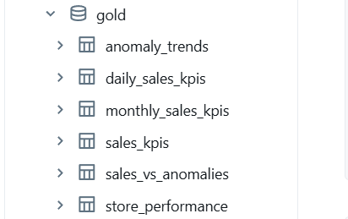
12.Run Jobs
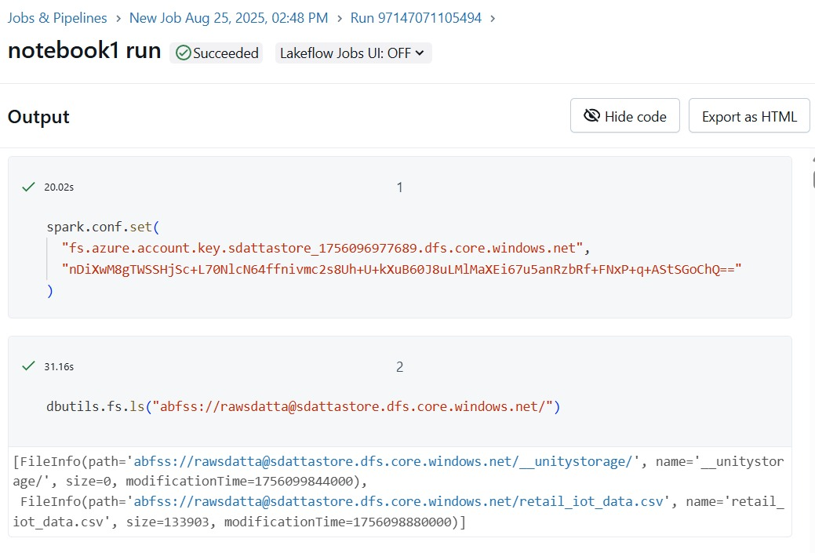
13. Integration with power bi

